Importance of culture in India and Iran ties

[Murtaza Ali Khan](javascript:void(0))

* Published

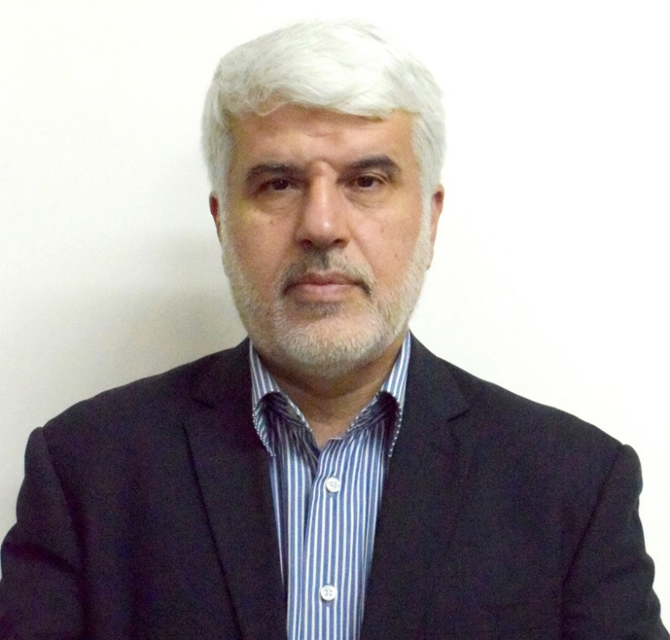

Dr. Mohd Ali Rabbani, the Cultural Counselor, Embassy of I.R. Iran and Head Iran Culture House, New Delhi, is responsible for organizing more than 15 International conferences in Iran and has published more than 50 academic articles in various international journals. He has a doctorate in history from University of Religions (Qom, Iran) and previously served as the editor-in-chief of ‘Society and Culture’ of Iran. He is also in charge of the English quarterly journal ‘Cultural dialogue’ being published in collaboration with JNU, Allama Taba Tabaie University (Iran) and Iran Culture House. Before coming to India, he visited Russia, Tunisia, Italy, Spain, and Turkey, among other countries. He is the honorary member of Iran Society Kolkata and will also be shortly confirmed as the member of Indian History congress.  
In this interview, Dr. Rabbani talks about the importance of culture in the relations between Iran and India, the significance of Persian and Sanskrit languages in the relations between the two countries, and impact of Covid-19 on socio-cultural issues and the field of art in Iran. Excerpts  
***Q. As the Cultural Counselor of the Iran in Delhi, what are your priorities for strengthening the cultural relations between India and Iran?***  
***A.*** The culture of the two countries has common components and undeniable similarities and has been the main intersection of Iran and India throughout the history of culture and civilization as well as Islam and Hinduism. India has many cultural-artistic connections and affiliations, which are manifested in literature, poetry, painting, architecture, etc. Therefore, today, we are trying to develop interactions between the intellectuals and academics of Iran and India through cultural dialogue and academic cooperation, the development of religious dialogue between Islam and Hinduism between Iran and India, the development of cinematic cooperation. Cooperation in the field of language teaching and written heritage; these are one of the priorities for strengthening and developing cultural relations between the two countries. We have tried to provide the grounds for the implementation of cultural agreements between the two countries, opportunities and suitable platforms to facilitate interactions and communication between the cultural and artistic sectors, especially in the field of cinema, media, which is one of the important capacities in the two countries.  
***Q. Please tell us about the activities of the Iran Culture House, New Delhi as well as the significance of culture in the relations between India and Iran?***  
***A.*** Iran Culture House of the Embassy of the Islamic Republic of Iran in Delhi, works on the basis of a cultural agreement concluded between the two countries and is responsible for developing cultural relations between Iran and India based on memorandums, cordialities and the agreements signed between the two countries. Iran Culture House, New Delhi is doing a series of cultural and artistic activities every year within the framework of these agreed views.  
The historical and cultural relations between Iran and India are considered to be one of the oldest and deepest human relations. No relation has been as close as the Iranians and Indians among the Indo-European communities. Dozens of books, hundreds of treatises and nearly a thousand articles have been written in Persian, English and other languages ​​about our historical and cultural relations with India. In these relations of several thousand years, India has influenced Iran and Iran had great cultural impact on India. The thought, style and hospitalities of the Iranian people in terms of theology, poetry, mysticism, wisdom and Sufism are similar to the Indian people. Basically, the basis of relations between Iran and India has been cultural for many centuries and culture has been considered as a facilitator of political and trade relations between the two nations.  
***Q. How do you assess the current state of cultural relations between India and Iran?***  
***A.***Although, the relations between Iran and India in the contemporary period have been accompanied by many political and social ups and downs, but this hasn’t disturbed the cultural relations between the two nations with a common, ancient and rich historical background. It is considered that naturally both the Iranian nation and the Indian nation have always had a positive attitude towards each other and the will of the two governments has been formed to preserve this common heritage and the continuation of intellectual and cultural interactions. It is one of the vast capacities that exist between the two countries for cultural cooperation. It is hoped that with a better understanding of the benefits that cultural cooperation can bring to the two great nations of India and Iran, a more appropriate situation of communication and cooperation can be created.  
***Q. How do you look at the significance of Persian and Sanskrit language in the relations between India and Iran?***  
***A.*** Sanskrit is the ancient language of the people of India and the religious language of the religions of Hinduism, Buddhism and Jainism, which is linguistically rooted in ancient Persian. The Sanskrit language belongs to the Indo-European language family. The Sanskrit language is very important for the etymology of Persian words. Since the roots of the Pahlavi language are indirectly related to the Avesta and Sanskrit languages, in order to achieve possible reserves in the Pahlavi literature, the need for this language is felt by linguists. Avesta is an example of Iranian literature and a storehouse of several thousand years of our ancient literature. Although today there is a big difference between Persian and Sanskrit, but the existence of many common and similar words between the two languages, indicates these two theories that the root of both languages ​​was the same. Rig Veda and the name of India in the book (Avesta) provide another confirmation of this theory.  
One of the most important elements of the common and precious heritage between India and Iran is the Persian language, which for many centuries flowed among the people of this region like a stream of water and thousands of poets, mystics and writers took sips from it and compiled extremely important books and works. At present, thousands of volumes of books in Persian on mysticism, literature, theology, commentary, lexicography, memoirs and history in libraries, cultural and academic centers and universities, and everywhere in this vast land speak of the common history of Iran and India. When the Pahlavi language was the official language of Iran, some Sanskrit books were translated into this language, and when the new Persian language appeared in Iran, it was also accepted in India. Modern Persian played an important role in the development of Urdu, Punjabi, Marathi and Bengali languages. Not to mention that Persian in India has had great poets and writers such as Amir Khusrow, Bidel Dehlavi, Mirza Ghalib and hundreds of other famous and great poets who lived and grew up in India and presented their literary works in this land.  
***Q. What measures have the Iran Culture House taken to strengthen and expand media cooperation between India and Iran?***  
***A.*** Today, the media play an important role in portraying and reflecting the existing realities among the nations. In addition to constructive interactions and relations with the media, we intend to provide the media with the necessary content to introduce the culture of Iranian civilization and society, and to provide their direct communication and presence in Iran to better understand the realities in Iran.  
***Q. Please tell us about the impact of Covid-19 on socio-cultural issues and the field of art?***  
***A.*** The emergence of Covid-19 is one of the great challenges of contemporary times that have had many effects on human life. This phenomenon in Iran, like other countries, in addition to human casualties and taking the lives of people who each had a role in society and whose death, had many destructive effects on society, including employment, business and education. It has also pursued in the fields of art and culture. Of course, it is necessary to mention that in addition to the damage that the pandemic caused to human societies, including the people of Iran, it also had positive effects and consequences, such as returning home, the importance of family and health, new experiences in cyberspace and digital space have been obtained, as well as the experience and scientific achievements of our researchers and thinkers in the production of vaccines. Let the human beings learn from the Covid-19 phenomenon that life and death are undeniable realities that can be made beautiful and lovable through peace, friendship and love for each other.